Economic instruments for supplying agrobiodiversity conservation

**Warwick Wainwright**

Doctor of Philosophy – The University of Edinburgh – 2018

Declaration

I, Warwick Wainwright, declare that:

1. This thesis was composed by myself
2. The work contained herein is my own, except where clearly stated
3. The work has not been submitted for any other degree or professional qualification
4. Included publications are my own work

Signed: ____________________

Dated: _________________

Abstract

Agrobiodiversity is declining across global farm production systems. These declines transcend both farm animal genetic resources (FAnGR) and plant genetic resources (PGR) – the focus of this PhD. Both can sustain greater adaptability and resilience in commercial production through so called ‘option value’. In addition, PGR and FAnGR embody cultural and heritage attributes that are often absent in UK and global agriculture, but remain valued by society. Conservation is therefore important and economic incentives represent a potential supply-side mechanism to improve the status of rare breeds, cultivars and crop wild relatives. Yet, the exploration of incentive tools in the context of PGR and FAnGR remains underexplored but may improve economic efficiency and conservation outcomes. Using different survey instruments and modelling approaches (including choice modelling, linear programming and multi criteria decision analysis) I investigate how rationalising incentive support, through more targeted interventions, could result in pro-conservation outcomes. Our findings suggest optimising subsidy support relies on three key factors. First, institutional and incentive support offered to farmers for conservation should reflect local circumstances, including addressing barriers-to-entry in conservation schemes. Second, identifying least cost suppliers of conservation services may enable more diversity to be conserved at comparable cost. Third, optimising what species, varieties and breeds are supported may improve conservation outcomes through more rationalised investments in diversity. Policy responses to address declining FAnGR and PGR should consider the use of tender instruments (i.e. reverse auctions) to identify least cost suppliers for conservation services. Optimisation modelling and decision analysis techniques can be used to measure trade-offs inherent in different conservation goals and ultimately balance the use and non-use values of diversity that are supplied through the total economic value framework. While the drive for sustainable intensification of production may improve productivity, we need to be clear how breed and cultivar diversity can be encompassed into future policy priorities that reflect the need for greater food security plus cultural and heritage value attributes. The implications of deploying new and potentially disruptive technologies (i.e. gene editing) in the context of farm diversity is discussed.

Graphical abstract

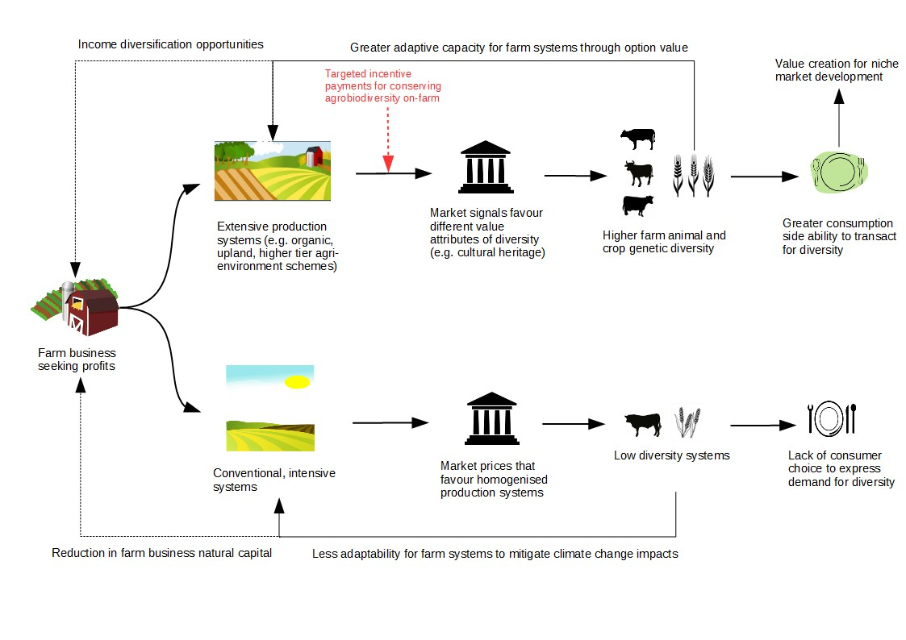

SCHMETIC REPRESENTATION OF OF THE MAIN AGENT PROCESSES AND INTERACTIONS WITHIN THE BREEDING SECTOR???



Lay summary

Acknowledgements

I would like to express thanks to my supervisors Professor Dominic Moran and Professor Geoff Simm for all their guidance and support throughout.

Thanks also goes too Adam Drucker (Bioversity International); Alistair McVittie, Bouda Ahmadi, Faical Akaichi and Klaus Glenk (SRUC); Libby Henson (Grassroots) and Tom Beeston and Ruth Dalton (Rare Breeds Survival Trust), for their continued support and assistance with fieldwork and chapter planning.

I would also like to acknowledge funding for this PhD project provided by the Natural Environment Research Council (NERC) E3 Doctoral Training Programme (DTP). I also acknowledge funding from Operation Wallacea and the SADC Crop Wild Relatives Project (FED/2013/330-210) co-funded by the European Union and implemented through ACP-EU Co-operation Programme in Science and Technology. I also acknowledge the support of the Scottish Government’s Rural and Environment Science and Analytical Services Division (RESAS) funding to SRUC.

Finally, I wish to thank my family, Aaron, Hadley, Clive and Heather Wainwright for putting up with me.

Table of Contents

Economic instruments for supplying agrobiodiversity conservation 1

List of abbreviations 1

Introduction 1

1.1 Agricultural production challenges 1

1.2 Agrobiodiversity is undersupplied 2

1.3 Economic incentives to supply more diversity 3

1.4 Aims and objectives 4

Valuing rare livestock breeds and farm animal genetic diversity: preferences, institutions and prospects 7

Contracts for supplying Farm Animal Genetic Resources (FAnGR) conservation services in Romania 8

Economic costs for in-situ conservation of Crop Wild Relatives (CWR) in Zambia: An application of Competitive Tender (CT) 9

Developing a prioritisation metric for conserving cattle native breeds at risk (NBAR) in the UK 9

Conclusion and recommendations 9

6.1 Conclusions 10

6.2 Recommendations 10

6.3 Further work 10

References 10

Appendix 10

List of tables

List of figures

**Figure 1:** Biodiversity and agrobiodiversity are reliant on sustaining natural capital and agroecosystems. The various elements that comprise agrobiodiveristy (biodiversity of relevance to food and agriculture) are outlined. Adapted from FAO, (2004). 2

List of abbreviations

AES Agri-environment scheme

ASC Alternative specific constant

BLP Binary linear programming

CE Choice experiment

CWR Crop wild relatives

FAnGR Farm Animal Genetic Resources

LP Linear programming

MCDA Multi-criteria decision analysis

Ne Effective population size

RPL Random parameters logit

PACS Payments for agrobiodiveristy conservation services

PCA Principal component analysis

PES Payments for ecosystem services

WTA Willingness to accept

WTP Willingness to pay

Chapter one

# Introduction

## Agricultural production challenges

Global agricultural production is at a crossroads. On the one side, the need to produce more food more cheaply is homogenising production systems with dramatic consequences for biodiversity, ecosystems and biomes. On the other, population growth, changing consumption patterns, rising incomes and globalisation are changing what, where and how much consumers consume. Global production of meat is projected to more than double from 258 million tonnes in 2006 to 455 million tonnes in 2050 whilst milk production is expected to grow from 664 to 1,077 million tonnes (Alexandratos and Bruinsma, 2012). Meanwhile, the Food and Agriculture Organization (FAO) has estimated annual global production of crops will need to increase by 60% from 2006 levels to 2050 to keep pace with rising demand (FAO, 2016).

Potential yield gains for crops and livestock are hindered by widespread land degradation, land scarcity, and climate change that threaten where and how much food we can produce. A review conducted for the Intergovernmental Panel on Climate Change (IPCC) suggests climate change will adversely affect crop yields post 2030 (Porter et al., 2014) and these impacts will vary regionally in response to precipitation variation and temperature change (De Pinto et al., 2016). For livestock, climate change related impacts will likely decrease meat and milk production primarily due to changing quality of forage (Chapman et al., 2012), pest/disease extent and prevalence (Nardone et al., 2010; Bett et al., 2017) and water availability (Thornton et al., 2009; Havlík et al., 2015). Bommarco et al. (2018) suggests retaining ecosystem services in agriculture is paramount to meeting these (food security) challenges.

Meanwhile farm systems worldwide are being homogenised in pursuit of productivity goals that are at the expense of local diversity and farm-systems resilience (Tscharntke et al., 2012). Yet, reduction in diversity increases vulnerability to climatic and other stresses, raises risks for individual farmers, and undermines the adaptability of agriculture to meet future drivers of change (Thrupp, 2000).

## Agrobiodiversity and undersupply

Agrobiodiversity (see Figure 1) can be broadly defined as all domesticated biodiversity (i.e. crops and livestock) within agricultural systems plus non-domesticated biodiversity that interplay in various ways with the health and functioning of agricultural systems (ref - Pascual et al., 2011). The former is declining primarily in response to farm intensification that has eroded natural capital in many agroecosystems (Chaplin-Kramer et al., 2015; Tsiafouli et al., 2015).

Today, an increasingly constrained set of plant and animal diversity is relied upon for global agricultural production. Only 15 animal species worldwide account for 90% of livestock production (Villanueva et al., 2004). For crops, just 12 plant species worldwide provide more than 70% of all human calorific intake (Frison et al., 2012). Within these species, increasingly few breeds and varieties are responsible for the overwhelming majority of production (FAO, 2015a; Gruber, 2017). Yet, the ability to grow crops and graze pastures in challenging environments, particularly those most affected by climate change, will require adaptive genetic resources. Work by Rojas-Downing et al. (2017) suggests crop and animal diversification are the most promising adaption measures and this can be mooted in the context of farm animal genetic resources (FAnGR) and plant genetic resources (PGR) for agriculture.

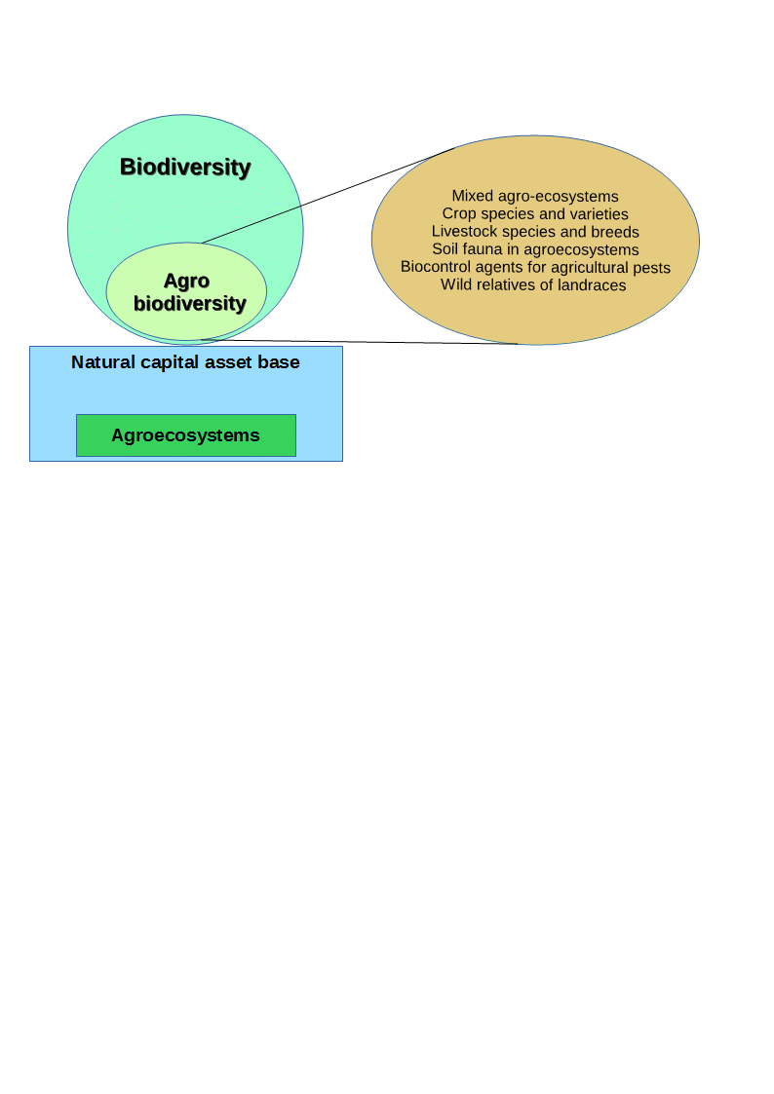

**Figure 1:** Biodiversity and agrobiodiversity are reliant on sustaining natural capital and agroecosystems. The various elements that comprise agrobiodiveristy (biodiversity of relevance to food and agriculture) are outlined. Adapted from FAO (2004).

FAnGR can be defined as the avian and mammalian species used for food production while PGR comprises cultivars and their wild relatives (FAO, 2015b). Both facets of diversity are undersupplied by markets and this can be appreciated via the economic conceptual framework. The former indicates diversity is a public good not captured by markets because it lacks an explicit market value (Pearce and Moran, 1994). Thus, it is not reflected in the true cost of food production and hence is undersupplied (Sustainable Food Trust, 2017). The resulting market failure has homogenised production landscapes worldwide (IPES-Food, 2016) and corrective measures are therefore necessary to supply more diversity through policies that govern food production and biological resource use.

The thesis therefore brings this issue into focus by first exploring the private and public good values of plant and animal genetic resources globally and second; by exploring measures to increase their supply. The need to conserve genetic resources for agriculture has been formally recognized by the Convention on Biological Diversity (CBD) Aichi Biodiversity Targets (CBD, 2013) and various international declarations[1]. The former have identified challenges including the need to design appropriate incentive mechanisms for conservation and develop decision support tools to guide investments in diversity (FAO, 2007, 2009).

Recent work by The Economics of Ecosystems and Biodiversity for Agriculture and Food (TEEBAgriFood) has stressed the importance of valuing natural capital in agroecosystems and the need to invest in agro-biodiversity for future food security (TEEB, 2018). The Intergovernmental Science-Policy Platform on Biodiversity and Ecosystem Services (IPBES, 2018) further stresses this need and suggests such investments make sound economic sense, i.e. the benefits generally far outweigh the costs.

Both facets of diversity are threatened by farm intensification (ref) and the need to conserve these genetic resources has been formally recognized by the Convention on Biological Diversity (CBD) Aichi Biodiversity Targets (ref, CBD) and various international declarations[2]. The former have identified challenges including the need to design appropriate incentive mechanisms for conservation and develop decision support tools to guide such investments (ref). This remains an underexplored area of work and my thesis develops this agenda further by building on previous work by Bioversity International (2018) exploring the use of payments for agrobiodiversity conservation services (PACS).

The Intergovernmental Science-Policy Platform on Biodiversity and Ecosystem Services (IPBES, 2018) has outlined the need to invest in biodiversity and ecosystem services and suggests such investments make sound economic sense, i.e. the benefits generally far outweigh the costs (TEEB, 2010). But while much work has explored the costs and benefits of preserving “naturally occurring” biodiversity, much less has focused on the supply and demand side aspects of agrobiodiversity.

Recent work by The Economics of Ecosystems and Biodiversity for Agriculture and Food (TEEBAgriFood) has stressed the importance of valuing natural capital in agroecosystems and the need to invest in agro-biodiversity for future food security (TEEB, 2018).

Diversity is a public good not captured by markets because it lacks an explicit market value and is therefore not reflected in the true cost of food production. This means diversity is often undersupplied through conventional markets and institutions, resulting in a market failure since diversity is not supplied at socially optimal levels (Pearce and Moran, 1994); although what these levels are remains up for debate. This has resulted in the homogenisation of production landscapes worldwide (IPES-Food, 2016) and corrective measures are therefore necessary to supply more diversity through policies that govern food production and biological resource use.

## Economic incentives to supply more diversity

Economic incentives provide a means to address market failures through a range of policy tools including regulation, taxation, certification, and subsides. Incentives work by influencing the behaviours of actors and firms through the alteration of market signals; thus correcting for market failure (Tietenberg and Lewis, 2018). Incentive schemes have become an increasingly popular way to address a range of environmental problems, including biodiversity loss. Incentives have been promoted because they offer more flexibility than traditional ‘command and control’ policies that require agents and firms to adhere to minimum standards or regulations.

This focus has been particularly evident in payments for ecosystem services (PES) schemes that reward landowners for supplying public goods. PES are voluntary incentive schemes where land managers can opt to supply a pre-defined service for a conservation payment, conditional on certain contractual obligations between the service provider and beneficiary (Farley and Costanza, 2010).

While economic incentives for conservation are proving more popular worldwide, a major constraint is funding limitations for conservation activities. Advancing our understanding of the cost effectiveness associated with different scheme designs is necessary and while this has been relatively well studied for some aspects of biodiversity conservation it remains comparatively underexplored in the context of agrobiodiveristy. Exploration of the latter may provide empirical basis to improve the design of schemes for better conservation outcomes. In this context, the technical design of schemes themselves may render them less effective at conserving certain value attributes of diversity (Börner et al., 2017) while approaches used to award contracts for supplying conservation services have also been shown to vary in efficiency (Windle and Rolfe, 2008; Duke et al., 2013).

PES type schemes have been formally adopted for plant and farm animal genetic resources conservation in Europe (Kompan et al., 2014; Poudel, 2015) but are relatively scarce on the global stage. Most schemes (though not all) provide payments to compensate yield gaps between traditional and improved varieties/breeds (Bojkovski et al., 2015). What most do not do is rationalise support based on different functions of cost and benefit (or endangerment). This shortfall is important since it means the selection of conservation agents (and ultimately the target of conservation effort) is not optimised for some objective, such as minimisation of cost or maximisation of diversity.

To improve conservation outcomes, it is necessary to incorporate such factors into the design of future incentive instruments. Additionally, the use of incentive schemes raises broader questions concerning fairness and distribution effects (Wunder, 2007; Jack et al., 2008; Narloch et al., 2013) as well as how investments in agrobiodiveristy should be rationalised to reduce redundancy and maximise return.

## Aims and objectives

The contribution of this thesis lies in the development of policy-relevant interventions that could be used to better support PGR and FAnGR conservation, in response to key research and policy challenges outlined by Cardellino and Boyazoglu, (2009), including the need to optimise resource allocation in conservation activities.

The thesis will provide a clearer picture of the private and public good values attached to rare breed conservation and how institutions may be working to ameliorate or exacerbate farm-diversity. Furthermore, this work improves our understanding of the likely costs of maintaining farm system diversity and the role of supply side instruments and incentives to affect (good) conservation outcomes, both in developed and developing countries.

The current supply of animal and, to a lesser extent plant diversity, is explored with a view to developing our understanding of the potential cost of supplying more diversity through incentive instruments. The former will broadly consider how contractual forms might be improved under existing agri environmental schemes (AES) or developed through stand-alone schemes (e.g. PES) where producers are rewarded for conservation effort. A mixture of diversity and endangerment metrics (e.g. numerical scarcity of breeding females and geographic concentration) are used to illustrate how interventions that target components of diversity can be more efficient than conventional conservation approaches.

The thesis is comprised of four studies. In Chapter 2, a review of public good characteristics associated with rare breeds is complimented by discourse surrounding how institutions are acting to exacerbate or ameliorate certain public good values embodied in rare breeds. Multiple proximate threats to diversity and issues pertaining to the use of incentive support schemes are discussed. Chapter 3 employs a choice experiment (CE) to determine farmer preferences for rare breed conservation contracts in Romania. Uptake in conservation programmes is modelled based on various payment scenarios related to farmer willingness to accept (WTA) conservation subsides. Barriers-to-entry that may preclude farmers from enrolling in incentive schemes are discussed, particularly in the context of small-scale producers where conservation arguably has a pivotal role to play.

In Chapter 4, a competitive tender survey is applied in Zambia to identify least cost conservation service providers for crop wild relatives (CWR) conservation. A linear programming (LP) model is used to demonstrate how selection of conservation sites and service providers can be optimised, subject to multiple diversity and social equity constraints. The appropriateness of selection under certain selection goals is discussed alongside resource needs and costs for national scale CWR conservation programmes. Chapter 5 provides an application of multi-criteria decision analysis (MCDA) to determine how livestock breeds (in the UK) could be prioritised to maximise returns on investments in diversity. Ethical arguments around prioritisation are provided alongside consideration of potential trade-offs between different conservation goals. Finally, Chapter 6 offers conclusions and recommendations from the thesis, plus suggestions for further work.

Chapter two

# Valuing rare livestock breeds and farm animal genetic diversity: preferences, institutions and prospects

Chapter three

# Contracts for supplying Farm Animal Genetic Resources (FAnGR) conservation services in Romania

Chapter four

# Estimating *in situ* conservation costs of Zambian Crop Wild Relatives under alternative conservation goals

Chapter five

# Prioritising rare breeds for incentive support: An application of multi-criteria decision analysis

Chapter six

# Conclusion and recommendations

## Main conclusions

* **Remind the reader of the research problem and purpose and how they were addressed.**

This research explored how the design of agrobiodiveristy conservation schemes could be made more (cost) effective. The modelling approaches (CE, BLP and MCDA) provide empirical assessment of different scheme designs and costs to meet demand for diversity value attributes that include use and non-use values. This is important because the application of economic models to improve cost effectiveness of PGR and FAnGR schemes are scarce, despite farm-scale intensification that threatens agrobiodiveristy. I address such a literature gap by exploring how supply and demand side aspects of conservation can be optimised as a function of biological, genetic and economic factors, including farmer preferences for conservation contracts.

* Briefly summarise what has been covered in the paper, by chapter.
* Make some kind of holistic assessment/judgement/ claim that pertains to the whole project (i.e., more than a descriptive summary)

There are concerns that incentives schemes may “crowd out” intrinsic motivations, such as people's moral commitment towards nature conservation (Luck et al., 2012) while others suggest incentives can induce “crowd in” positive actions for conservation Additionally, the use of incentive based schemes raises broader questions concerning fairness and distribution effects (Wunder, 2007; Jack et al., 2008; Narloch et al., 2013) as well as how cost effective different schemes designs prove to be. Other problems may include lack of additionality (i.e. paying for activities that would have been conducted anyway) and leakage (i.e. shifting environmentally-damaging activities elsewhere).

## Recommendations

* Assess the value/relevance/ implications of the key findings in light of existing studies and literature.
* Outline implications of the study (for theory, practice, further research).
* Make claims for new knowledge/ contribution to knowledge.

## Further work

* Refer to the limitations of the studies that may affect the validity or the generalisability of results.
* Make recommendations for further research.

# References

# Appendix

1. The International Treaty on Plant Genetic Resources for Food and Agriculture (ITPGRFA) was effective from 2004 while the Global Plan of Action (GPA) for FAnGR was adopted in 2007.
2. The Global Plan of Action (GPA) for FAnGR was adopted in 2007while the International Treaty on Plant Genetic Resources for Food and Agriculture (ITPGRFA) was adopted in 2014.